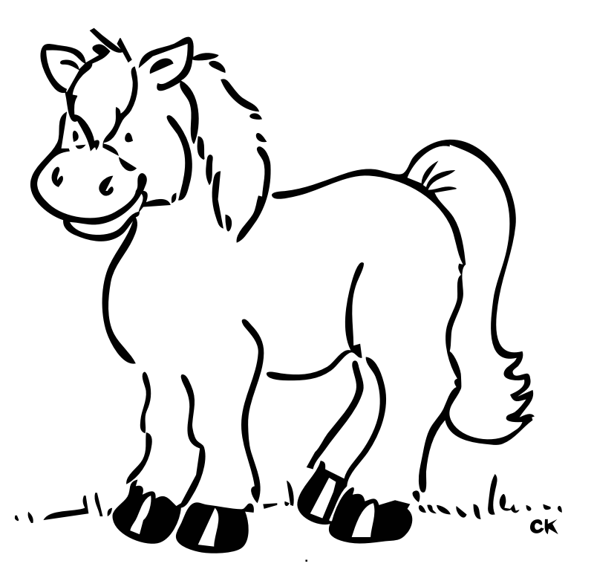

We are glad you have chosen to have a birthday party at Silver Lining Farm!
Attached is a copy of the waiver that must be signed by each PARENT whose children will be participating in the party. Please have these waivers turned in before the party starts. Any child that does not have a waiver signed by a parent will NOT be able to ride.
Your birthday party is set for two hours. The children will be able to ride for approximately one hour and fifteen minutes. Usually there is one horse to every 2-3 children. After riding, we will take the children on a hayride through the property.
We suggest you bring some drinks such as capri sun, and possibly some snacks along with your cake. We have tables, chairs, and tablecloths by the riding ring.
You can also bring treats for the horses! They enjoy carrots and apples!
Please advise parents to dress their children in clothes suitable for riding. This includes long pants and boots if possible. We will provide helmets.
You can include up to 15 children riders for the price of the party. Each child thereafter will cost $10 extra per child.
Please clean up your trash when you leave. You can either take it with you or give it to us.
No smoking is permitted on the farm.
Thank you for having your birthday party with us!!

Waiver of Liability and Indemnity

I understand that all horse related sports carry the risk of serious physical injury and even
death. I accept the fact that if I or any of my children participate in horse related sports,
we may injured, incapacitated, or even killed. I understand that horses are unpredictable
and that human beings handling them make errors.

I hereby release and agree to hold harmless any member of the Marybeth C. Peters
family, any member of the Davis Pilot family, or any of their heirs, and any employee or
volunteer of Marybeth Peters, from any and all injury to my child or any member(s) of
my family, including me, even if this injury is due to negligence or carelessness on the
part of the released persons.

This means that if any of us are injured, disabled, or killed in connection with riding the
horses at Silver Lining Farm regardless of whether horses are actually involved, I
relinquish all legal and financial recourse and agree not to sue any of the released
persons. I also agree that in the event any of the released persons are sued on account of
injury to me or a member of my family, I will defend the released persons and hold them
harmless from account of all liability and cost claimed on account of such injury.

WARNING…Under Alabama Law, an equine activity sponsor or equine professional is not liable for an injury or death of a participant in equine activities resulting from the inherent risks of equine activities, pursuant to the Equine Activities Liability Protection Act.

I recognize that the released persons permit me to ride their horses only in reliance on this
waiver and indemnity. I recognize that the signatures below are the signatures of the
custodial parents of:

__________________________ ___________________________
Print Riders’ Names(s)

__________________________ ___________________________
Signatures of Both Parents Date

__________________________ ___________________________
Print Parents’ Names

________________________________________________________________________
Address and Phone Number of Rider(s)

________________________________________________________________________
Email Address of Rider(s)

___________________________
Signature of Witness

